EXP-23:

Aim: To Design Deterministic Finite Automata using simulator to accept the string the end with ab over set {a,b) W= aaabab.

Diagram:

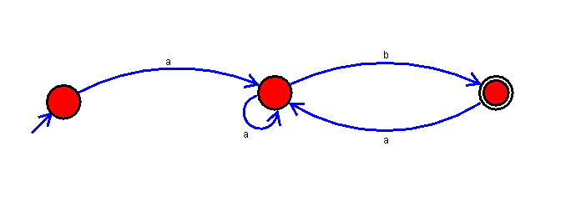

Result:

Successfully executed Deterministic Finite Automata using simulator to accept the string the end with ab over set {a,b) W= aaabab.